21) When implementing linear regression of some dependent variable 𝑦 on the set of independent

variables 𝐱 = (𝑥₁, …, 𝑥ᵣ), where 𝑟 is the number of predictors, which of the following statements will

be true?

1. 𝛽₀, 𝛽₁, …, 𝛽ᵣ are the regression coefficients.
2. Linear regression is about determining the best predicted weights by using the method of ordinary least squares.
3. E is the random interval
4. Both a and b

# The correct option is d) both a and b

22 ) What indicates that you have a perfect fit in linear regression?

1. The value 𝑅² < 1, which corresponds to SSR = 0
2. The value 𝑅² = 0, which corresponds to SSR = 1
3. The value 𝑅² > 0, which corresponds to SSR = 1
4. The value 𝑅² = 1, which corresponds to SSR =0

The correct option is d) d) The value 𝑅² = 1, which corresponds to SSR = 0. The value 𝑅² = 1 indicates that the regression predictions perfectly fit the data.

1. In simple linear regression, the value of what shows the point where the estimated regression line crosses the 𝑦 axis?
2. Y
3. B0
4. B1
5. F

# The correct option is b) B0

1. Check out these four linear regression plots:

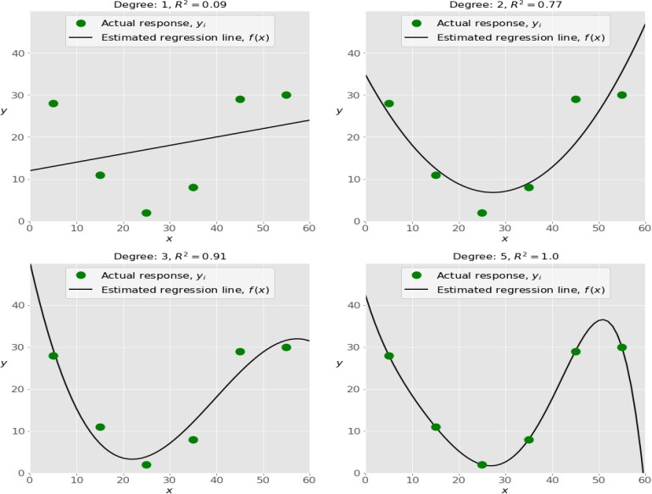

Which one represents an underfitted model?

1. The bottom-left plot
2. The top-right plot
3. The bottom-right plot
4. The top-left plot

# The correct option is a) The bottom- left plot

1. There are five basic steps when you’re implementing linear regression:

* a. Check the results of model fitting to know whether the model is satisfactory.
* b. Provide data to work with, and eventually do appropriate transformations.
* c. Apply the model for predictions.
* d. Import the packages and classes that you need.
* e. Create a regression model and fit it with existing data.

However, those steps are currently listed in the wrong order. What’s the correct order?

* 1. e, c, a, b, d
  2. e, d, b, a, c
  3. d, e, c, b, a
  4. d, b, e, a, c

# The correct option is d) d, b, e, a, c

26 ) Which of the following are optional parameters to LinearRegression in scikit-learn?

1. Fit
2. fit_intercept
3. normalize
4. copy_X
5. n_jobs
6. reshape

# The correct answer is b) fit intercept c) normalize d)copy X e) n jobs

1. While working with scikit-learn, in which type of regression do you need to transform the array of

inputs to include nonlinear terms such as 𝑥²? a)Multiple linear regression

1. Simple linear regression
2. Polynomial regression

# The correct answer c) Polynomial regression

1. You should choose statsmodels over scikit-learn when: a)You want graphical representations of your data.
2. You’re working with nonlinear terms.
3. You need more detailed results.
4. You need to include optional parameters.

# The correct answer is a)You want graphical representations of your data.

1. **You’re working with nonlinear terms.**

# You need more detailed results.

1. **You need to include optional parameters.**
2. is a fundamental package for scientific computing with Python. It offers

comprehensive mathematical functions, random number generators, linear algebra routines,

Fourier

transforms, and more. It provides a high-level syntax that makes it accessible and productive.

1. Pandas
2. Numpy
3. Statsmodel
4. scipy

# The correct answer is b) Numpy

30 ) is a Python data visualization library based on Matplotlib. It provides a high- level

interface for drawing attractive and informative statistical graphics that allow you to explore and

understand your data. It integrates closely with pandas data structures.

1. Bokeh
2. Seaborn
3. Matplotlib
4. Dash

# The correct answer is c) Matplotlib